19.33: a)

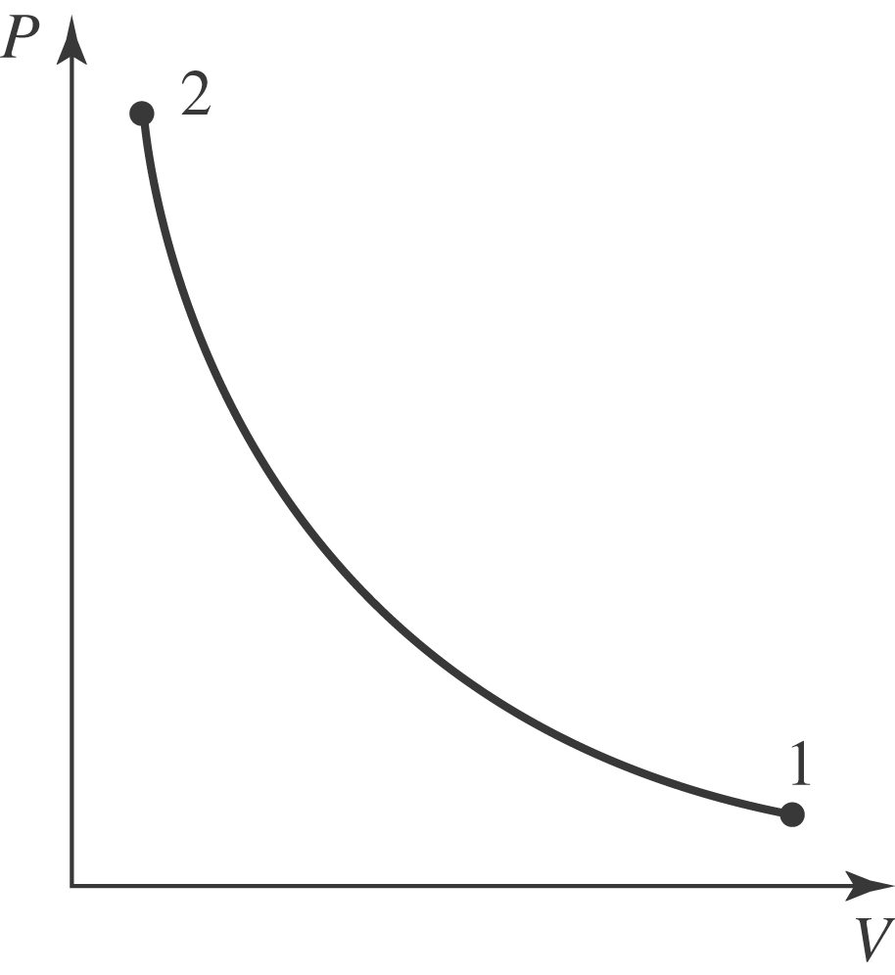

From Eq. (19.22),

and from Eq. (19.24),

